

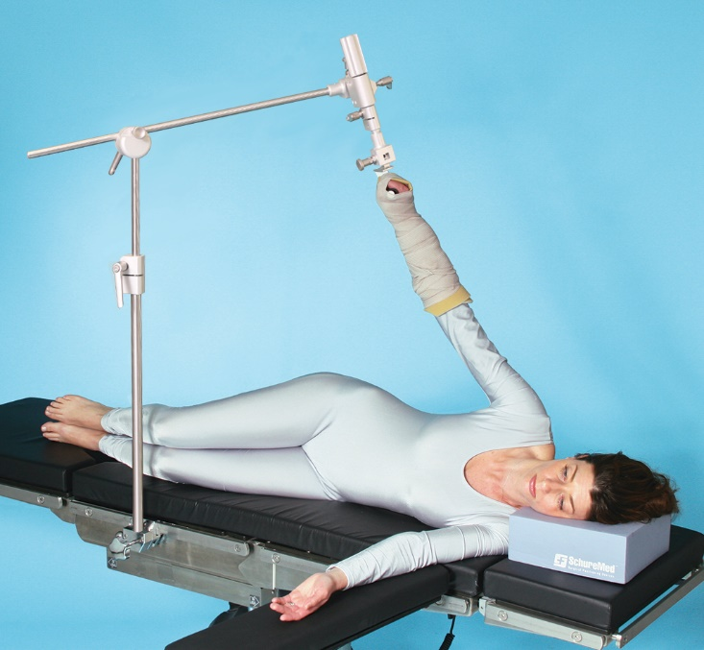**Instructions for Use**

**Lateral Shoulder Holder   800-0169**  
  
***Required Disposables*  
SchureLoc Sterile, Disposable, 10/cs 800-0281**

**INTENDED USE**  
Intended use is to provide traction and intra-operative positioning during supine elbow surgery and rotation of operative shoulder during shoulder surgery controlled by surgeon’s preference. The intended users of this device are medical professionals within hospitals and surgery centers.

**GENERAL SPECIFICATIONS**  
*Device Dimensions (maximum)*

* Length: 31” +/- 0.5” (79cm +/- 1 cm) (extended), 9” +/- 0.5” (23 cm +/- 1 cm) (collapsed)
* Range of Motion: 360° Rotation
* Height: 48” +/-  0.5” (122 cm +/- 1 cm) (extended), 26.5”+/- 0.5” (67 cm +/- 1 cm) (collapsed)
* Device Weight: 12.5 +/- 0.5 lbs. (5.6+/-.22 kg)Single-person installation

**SUB-ASSEMBLY IDENTIFICATION**

(**1**) 790-0061  •  (**2**) 790-0011  •  (**3**) 790-0013 •   (**4**) 790-0014  •  (**5**) 790-0015  •  (**6**) 800-0281

6

5

4

3

2

1

1

**INSTRUCTIONS**Become familiar with patient positioning device’s features before use with patient. Always practice on a nurse, physician or appropriate volunteer prior to using clinically.

**ATTACHING LATERAL SHOULDER HOLDER TO SURGICAL TABLE**

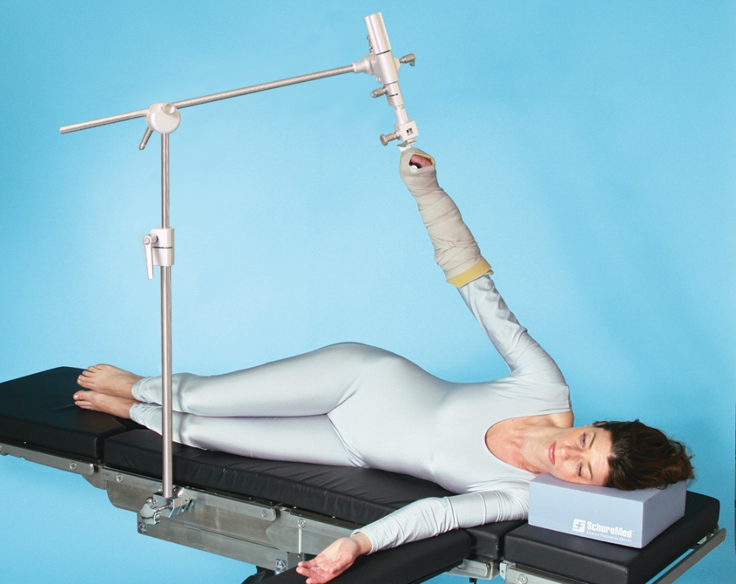

Step 1

Step 2

Step 4

Step 3

Step 5

1. Attach clamp (sold separately) over drape along surgical table side rail where there are no notches.  
   **Note: CamLoc locks to rail from the bottom. Clamp cannot be attached where there is a notch on side rail – it will not be secured or locked.**
2. Insert 790-0011 into clamp and tighten handle to lock into place
3. Loosen lever handle and insert 790-0013 into 790-0011. Adjust to desired height and lock lever handle tight.
4. Loosen handle and pull plunger to slide 790-0014 into 790-0013. Rotate 790-0014 to desired position, lock handle and release plunger.
5. Insert 790-0015 into appropriate slot for desired position, listen for click

**Placing and Securing the Patients Arm with Disposable Forearm Wraps (800-0281)**

Forearm Attachment Handle

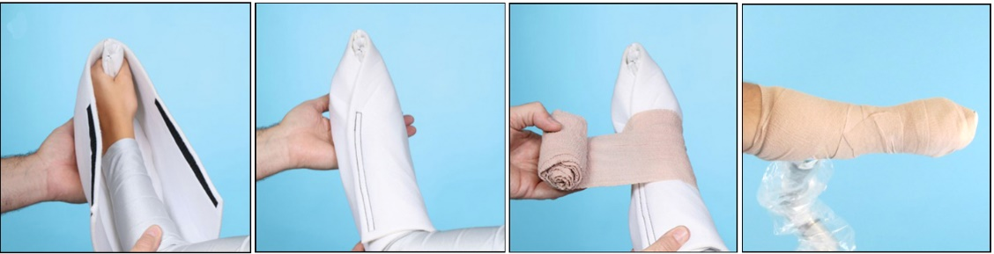

1

2

3

4

1. Place patient arm into Forearm Pad, ensuring patient’s fingers wrap around Forearm Attachment Handle and wrap pad snugly around patient's arm. See Figures 1-2.
2. Using self-adherent wrap, secure patients arm to forearm attachment by wrapping entire assembly. Be sure to secure hands and fingers with wrap. See Figures 3-4.

**INSTRUCTIONS FOR USE OF LATERAL SHOULDER HOLDER**

|  |  |
| --- | --- |
| A person posing for the camera  Description automatically generated  Step 3  Step 2  Step 1 | 1. Insert 790-0061 into appropriate slot of 790-0015. The plunger will pop into place. 2. Loosen handle to allow rotation of arm. Tighten handle when arm has reached desired position. 3. For traction turn knob right to tighten and left to loosen |

**REMOVING LATERAL SHOULDER HOLDER**

|  |  |
| --- | --- |
| Step 4  Step 3  Step 2  Step 1  Step 5 | 1. Pull plunger to remove arm from device. Unwrap arm. 2. Release plunger to remove traction system (790-0015) 3. Pull plunger and loosen handle to release (790-0014) 4. Loosen lever to remove pole (790-0013) 5. Loosen clamp and remove (790-0011) |

**COMPONENT OVERVIEW**  
Lateral Shoulder Holder is a device used during shoulder surgery. Its function is to provide traction and rotation of the operative shoulder controlled by the surgeon’s preference, during shoulder surgery.

A CamLoc Rail Clamp (sold separately) is required to attach Lateral Shoulder Holder to surgical table and Schure Loc XPS Sterile Kit that attaches patient limb to the Lateral Shoulder Holder.

* US: 0.374” x 1.122” (9.5 mm x 28.5 mm) PN# 800-0271
* **Denyer**: 0.236” x 1.496” (6 mm x 38 mm) PN# 800-0271-DEN
* **Europe**: 0.394” x 0.984” (10 mm x 25 mm ) PN# 800-0271-EU
* **Eschmann (UK)**: 0.236” x 1.260” (6 mm x 32 mm) PN# 800-0271-UK
* **Japan**: 0.354” x 1.260” (9 mm x 32 mm ) PN# 800-0271-JPN
* **Swiss**: 0.394” x 1.181” (10 mm x 30 mm ) PN# 800-0271-SWISS

***Required Disposables*  
SchureLoc Sterile, Disposable, 10/cs 800-0281**  
  
**GENERAL INFORMATION**

* Product not made with Natural Rubber Latex
* Product warranty covers product from manufacturing defects for period of 2 years
* If damaged in shipping, call Customer Service at (888) 724-8763 or (781) 982-7000 to obtain Return Material Authorization number. For product warranty issues, contact Customer Service.
* CE marked medical device according to MDR (EU) 2017/745
* Life of device is 3 years under normal use
* Store device between -4°F to +86°F (-20°C to 30°C)

**DISPOSAL**

* **General**- Prevent infection by cleaning and disinfecting product before disposal
* **Packaging** - Dispose packaging material via household waste according to national requirements
* SchureMed accepts back used or retired products - or dispose of product in accordance with national requirements

**  
PRODUCT USE WARNINGS  
WARNING!**  
*Maximum load should not exceed appropriate proportion of a patient weighing 500 lbs. (227 kg). Use care with low-maximum load capacity surgical tables that accessory rails are not overloaded.*

**  
WARNING!**  
*Hazard resulting from incorrect use. Strictly follow Instructions for Use with your Operating Table system.*

  
***WARNING!*** *Do not reuse device if there are obvious signs of damage or functional issues. Consult manufacturer before reusing.*

**CLEANING RECOMMENDATION**  
***Follow current Association of periOperative Registered Nurses Journal Guidelines for proper cleaning and disinfection procedure.***  
  
  
**WARNING!**  
***Adhere to standards for blood-borne pathogens from the Occupational Safety and Health Administration. Use recommended protective clothing, gloves, masks and eye protection to clean accessory.***

# CAUTION

## Strictly read/follow manufacturer’s directions for cleaning fluids. DO NOT use cleaners containing

**phenolics.**

1. *Remove major contaminants from accessory with disposable materials. Follow appropriate bio-hazard waste disposal procedures.*
2. *Apply cleaning fluid liberally to entire accessory and wipe with clean, lint-free cloth until all moisture and cleaning fluid is removed from accessory*
3. *Let accessory dry*

**CLEANING AND STERILIZATION INSTRUCTIONS**

* Clean Lateral Shoulder Holder thoroughly before using (before sterilization) and after each use
* Recommended cleaning products: (All solutions should be used in accordance with manufacturer’s instructions)

- *Enzymatic neutral pH detergent solution*

- *(Enzymatic cleaners are compatible with metal devices/instruments and are preferred)*

- *Non-enzyme, hydrogen peroxide based solution*

- *Coverage Plus NPD One Step Cleaner, Disinfectant & Deodorizer Concentrate*

* Disassemble Lateral Shoulder Holder into separate parts for cleaning: 790-0014, 790-0013, 790-0011, 790-0015 & 790-0061

**Hand Cleaning**

* Scrub each piece with a soft, plastic scrub brush and a recommended cleaning solution (see above)
* Rinse all parts thoroughly to remove any chemical residue
* Wipe each part completely dry with a clean, lint-free cloth

**Washer Cleaning**

* Put through washer/decontaminator according to manufacturer’s instruction (Select cycle that does not included lubrication)
* Prepare for sterilization (device must be cleaned before sterilization)
* See sterilization instructions below

*\*Based on information provided by the Healthcare Infection Control Practices Advisory Committee (HICPAC), the Center for Disease Control (CDC), the National Center for Biotechnology Information (NCBI) and the U.S. National Library of Medicine.*

**Pre-Vacuum Sterilization *Wrapped Instruments****Exposure Time at 132°C (270°F): 4 minutes  
Drying Time: 40 minutes*

**USER NOTICE**  
*Any serious incident that has occurred in relation to the device should be reported to the manufacturer and the competent authority of the Member State in which the user and/or patient is established.*

**eIFU Language Versions**

To download and print the Instructions for Use, please go to [www.schuremed.com](http://www.schuremed.com).

**Symbol Glossary**

|  |  |
| --- | --- |
| **Symbol** | **Title** |
|  | Manufacturer |
|  | Date of manufacture |
|  | Authorized Representative in the European Community |
|  | Authorized Representative in the Swiss |
|  | Importer |
|  | Serial Number |
|  | Warning |
|  | Medical Device |
|  | Unique Device Identifier |
|  | CE Marking |
|  | Single Patient Use |



**Manufacturer**  
**SchureMed** (081001460)  
452 Randolph Street, Abington, MA 02351 USA   
**Toll Free** (888) 724-8763  |  **Ph** (781) 982-7000 |  **Fax** (781) 982-7001  |  [**orders@schuremed.com**](mailto:orders@schuremed.com)